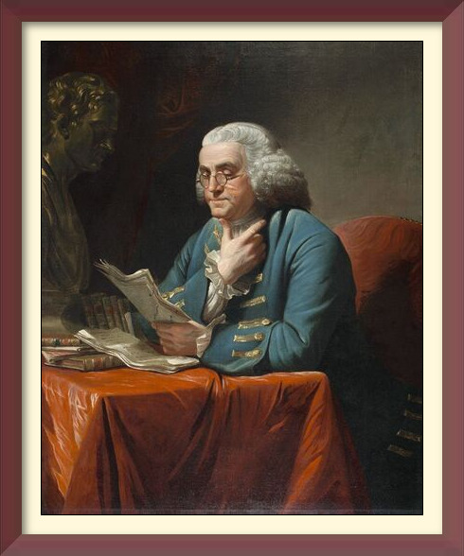
SPONSORED BY
SOUTH CAROLINA SOCIETY
SONS OF THE AMERICAN REVOLUTION
The South Carolina Society Education Committee vision is to utilize the Benjamin Franklin Reading Program to perpetuate knowledge of the American Revolution and our founding fathers to the youth of our state. The founding documents and stories of patriotism, courage, sacrifice, tragedy and triumph of American patriots, many from South Carolina, who achieved independence for the American people.
It is our belief that these stories are universal ones of man’s struggles against tyranny, relevant to all time, and will inspire and strengthen each succeeding generation as it too is called to defend our freedoms on the battlefield and in our public institutions.
This program seeks to encourage students of all grades to read about the American Revolution and the Founding Fathers. Students receive a certificate and $25.00 Dollars for reading five books about the American Revolution, the Founding Fathers or other aspects of American Foundation History. A parent, guardian or teacher certifies that the student has read these books and returns the statement to the local chapter. There is no deadline for participation.
Interested in earning a certificate and $25.00 for reading about the American Revolution and our founding fathers? Read five books on these topics and send the following information to educationchair@scssar.org to also receive a Reading is Patriotic certificate: You may also complete your information on the form provided within our website.

- Your full name
- School name
- Book titles and authors
- Home / email address where Reading is Patriotic Certificate should be sent

Send a photo/video of your child/student reading one of their patriotic books to webmanager@scssar.org and we may feature it on the South Carolina Society SAR website!

Shown below are great representative samples of pre-high school books possibly available in your local library. The high school student will undoubtedly want to select their own qualifying books of interest.

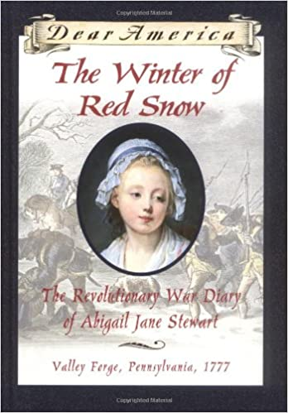
Reading is Patriotic Elementary Level Recommended Reading List

The Winter of Red Snow: The Revolutionary War Diary of Abigail Jane Stewart, Valley Forge, Pennsylvania, 1777
By Kristiana Gregory
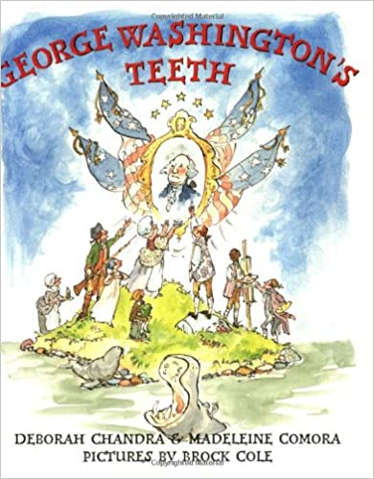
(Age Range: 9-12, Grade Level: 4-6)

George Washington’s Teeth
By Deborah Chandra and Madeleine Comora
(Age Range: 4-8, Grade Level: PK-3)
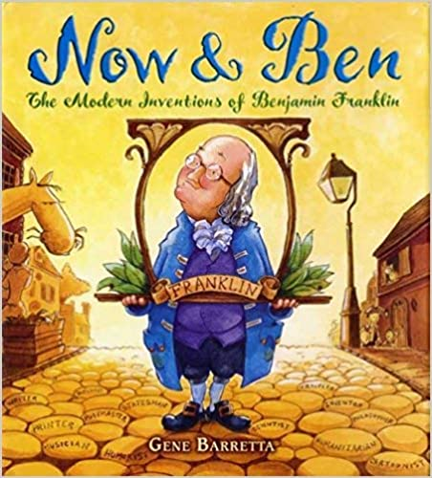

Now & Ben: The Modern Inventions of Benjamin Franklin
By Gene Barretta
(Age Range: 4-8, Grade Level: K-3)
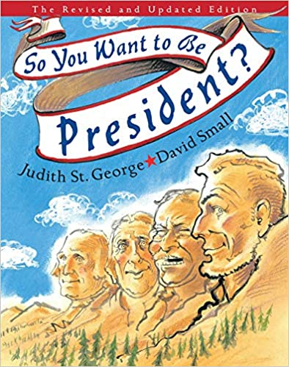

So You Want to Be President?
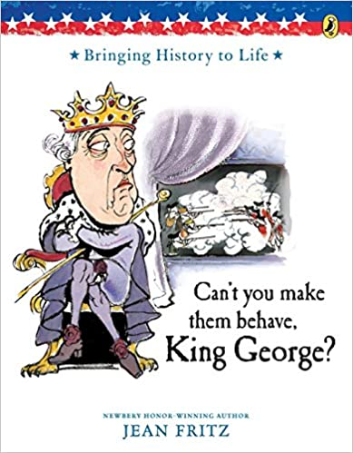
By Judith St. George, illustrated by David Small
(Age Range: 7-10, Grade Level: 2-5)

Can’t You Make Them Behave, King George?
By Jean Fritz, illustrated by Tomie dePaola
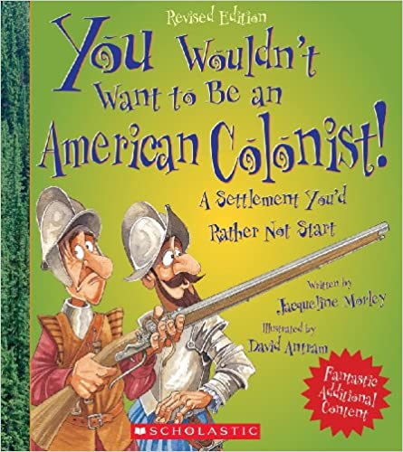
(Age Range: 7-10, Grade Level: 2-5)

You Wouldn't Want to Be an American Colonist!: A Settlement You'd Rather Not Start
By Jacqueline Morley, illustrated by David Antram
(Age Range: 8-11, Grade Level: 3-6)
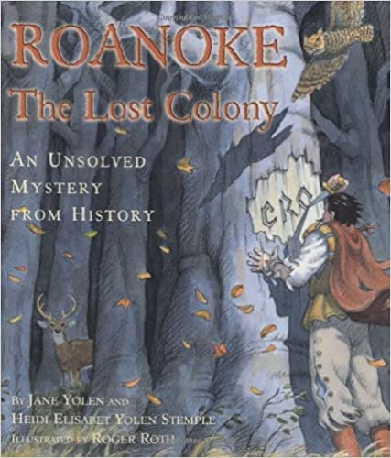
The Lost Colony of Roanoke
By Jean Fritz and Thomas Preston, illustrated by Hudson Talbott
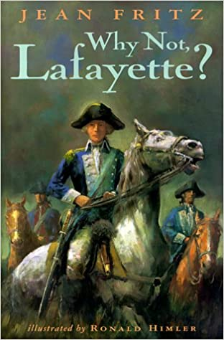
(Age Range: 6-10, Grade Level: 1-5)

Why Not, Lafayette?
By Jean Fritz
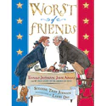
(Age Range: 8-12, Grade Level: 3-7)

Worst of Friends: Thomas Jefferson, John Adams and the True Story of an American Feud
By Suzanne Tripp Jurmain, illustrated by Larry Day
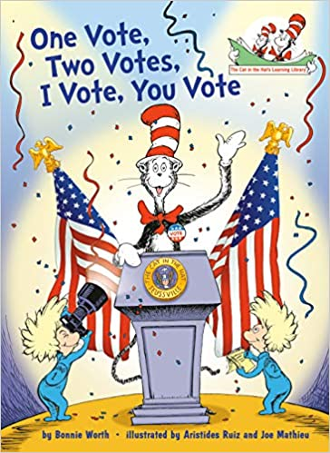
(Age Range: 6-8, Grade Level: 1-3)

One Vote, Two Votes, I Vote, You Vote
By Bonnie Worth, illustrated by Aristides Ruiz and Joe Mathieu
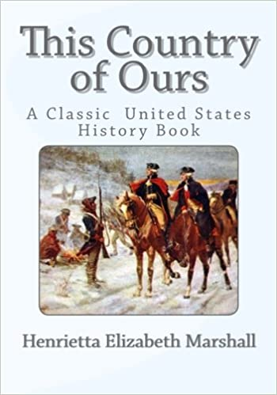
(Age Range: 5-8, Grade Level: K-3)

This Country of Ours: The Story of the United States
By Henrietta E. Marshall
(Age Range: 7-10, Grade Level: 2-3)
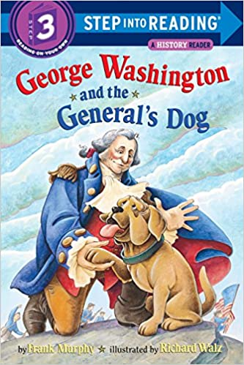

George Washington and the General’s Dog
By Frank Murphy
(Age Range: 5-8, Grade Level: K-3)
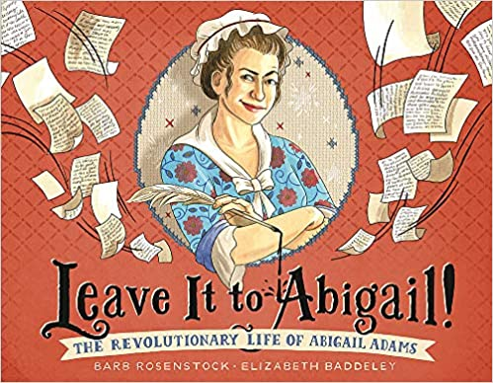
Leave it to Abigail!: The Revolutionary Life of Abigail Adams
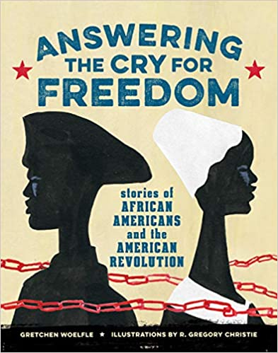
By Barb Rosenstock, Illustrated by Elizabeth Baddeley
(Age Range: 4-8, Grade Level: PK-3)

Answering the Cry for Freedom
By Gretchen Woelfle
(Age Range: 9-12, Grade Level: 4-7)
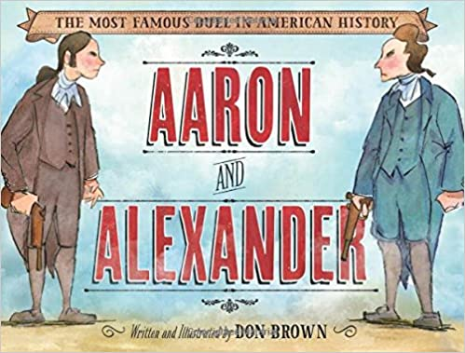
Aaron and Alexander: The Most Famous Duel in American History
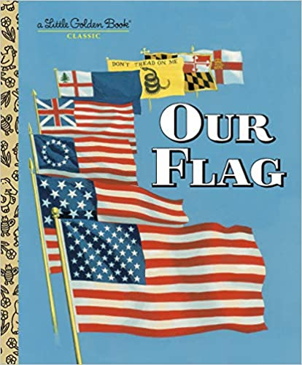
By Don Brown
(Age Range: 5-7, Grade Level: K-2)

Our Flag
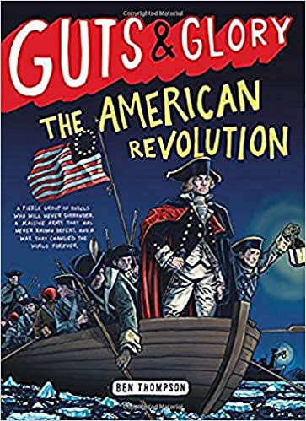
By Carl Memling, Illustrated by Stephen Cook
(Age Range: 3-7, Grade Level: PK-2)

Guts and Glory: The American Revolution
By Ben Thompson
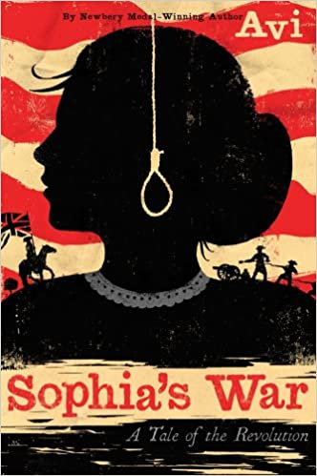
(Age Range: 8-12, Grade Level: 3-7)

Sophia’s War: A Tale of the Revolution
By Avi
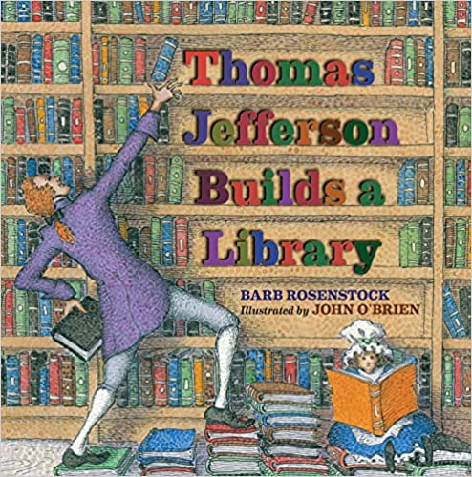
(Age Range: 8-12, Grade Level: 3-7)

Thomas Jefferson Builds Library
By Barb Rosenstock, Illustrated by John O’Brien
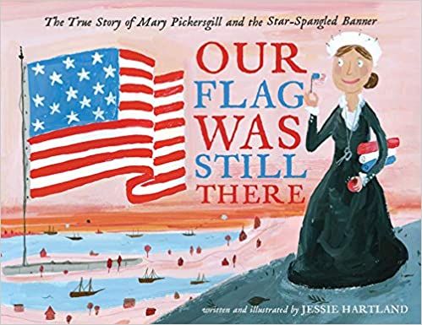
(Age Range: 8-12, Grade Level: 3-6)

Our Flag Was Still There: The True Story of Mary Pickersgill and the Star-Spangled Banner
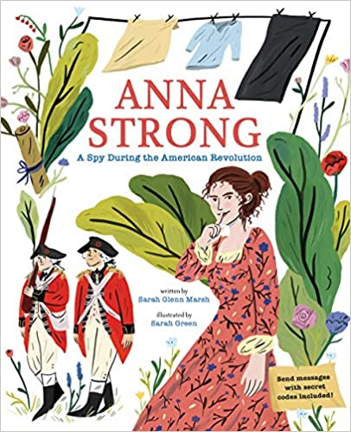
By Jessie Hartland
(Age Range: 4-8, Grade Level: PK-3)

Anna Strong: A Spy During the American Revolution
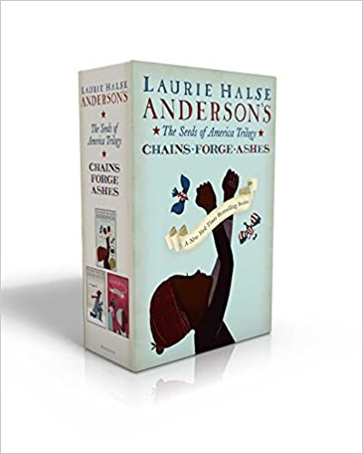
By Sarah Glenn Marsh, Illustrated by Sarah Green
(Age Range: 4-8, Grade Level: PK-3)

The Seeds of America Trilogy: Chains; Forge; Ashes
By Laurie Halse Anderson
(Age Range: 10-14, Grade Level: 5-8)

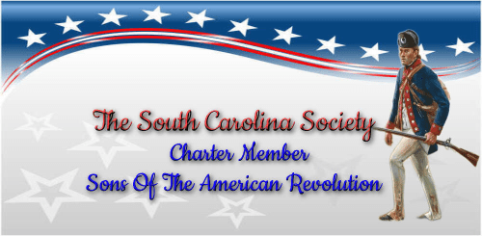

Property of the South Carolina Society SAR
Available to all patriots
(This brochure is a printable Microsoft word document)

